Securing Network Resources

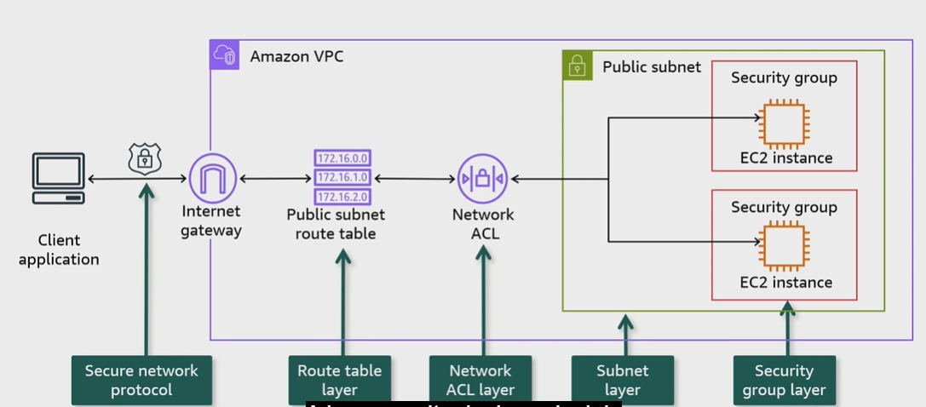
A. AWS Physical Infrastructure:

B. Security Groups and Network ACL Scope
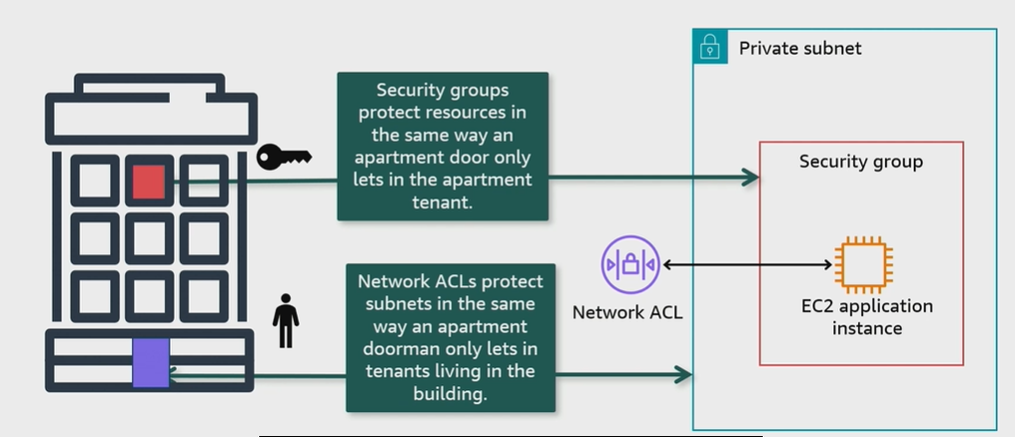

C. Security Groups

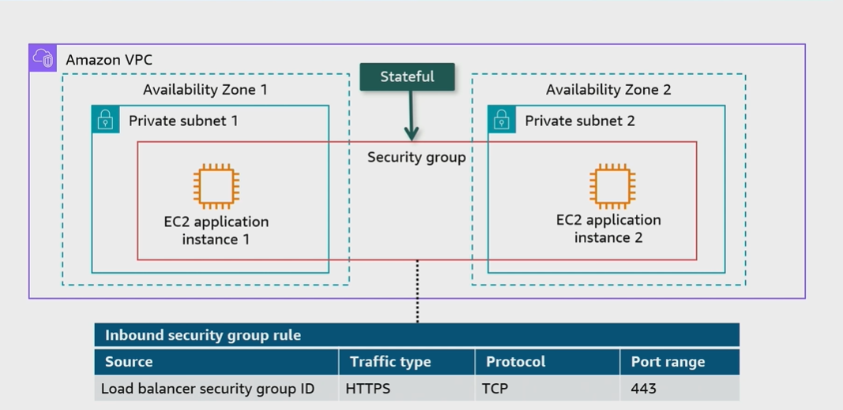
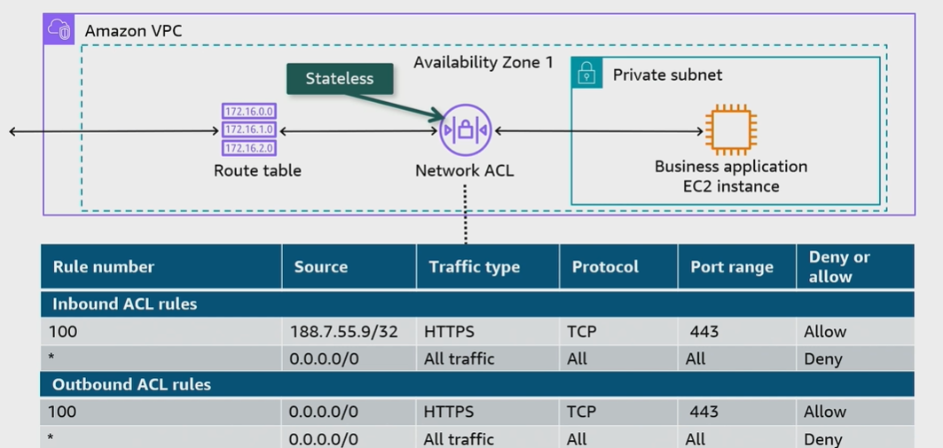
D. Networl ACL

E. Comparing security groups versus Network ACLs
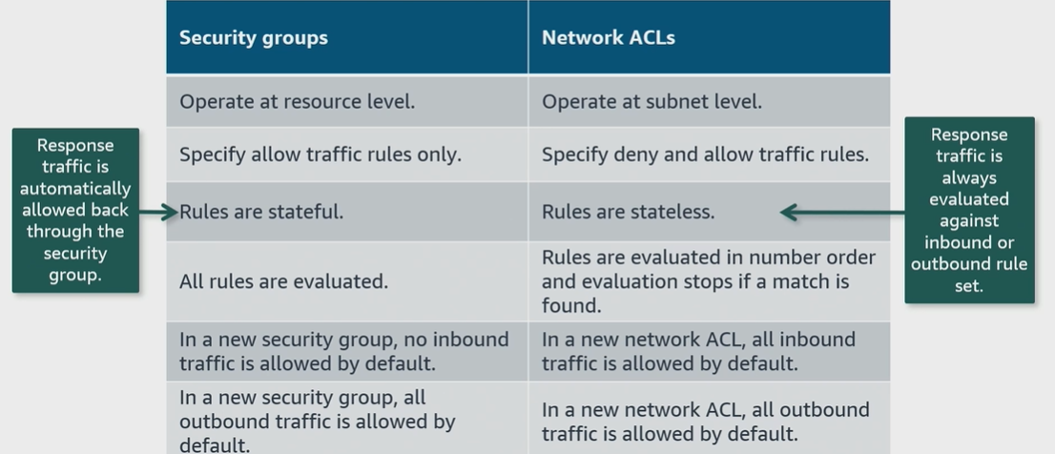

F. AWS Network Firewall
- Network firewall and instrusion detection and prevention service for an Amazon VPC
- Adds an additional layer of security.
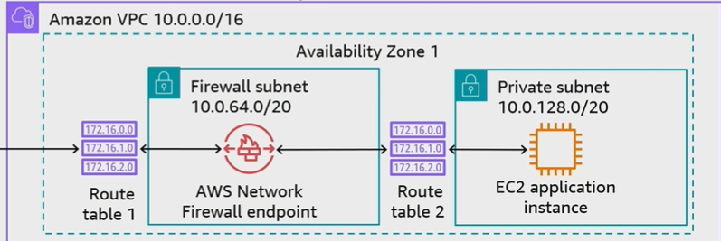
- Routes external VPC traffic through AWS Network Firewall to protect subnet resources.

G. Assessing resources with bastion hosts

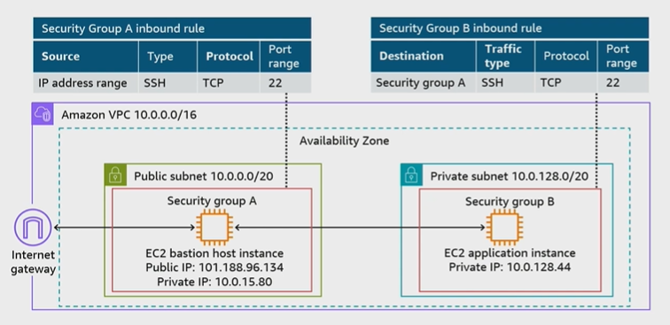
H. Conclusions
- Secure AWS Infrastructure with multiple layers of defense
- A security group in a VPC specifies which traffic is allowed to or from AWS resources. It is stateful
- A network ACL allows or denies specific inbound or outbound traffic at the subnet level, it is stateless
- Route external VPC traffic through AWS Network Firewall to add an additional layer of traffic security
- Use a bastion host to administrate private subnet resources from an on-premises environment.

